On December 29, 2003, I went to visit La Casa de Elián, a museum dedicated to the young boy who became the center of an international crisis. But take a closer look at this infamous photo of a federal agent snatching Elián from the home of his Miami relatives.

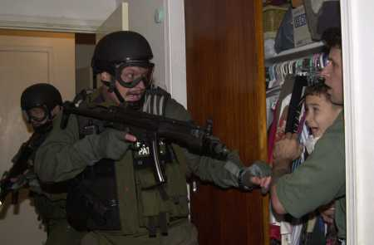 | 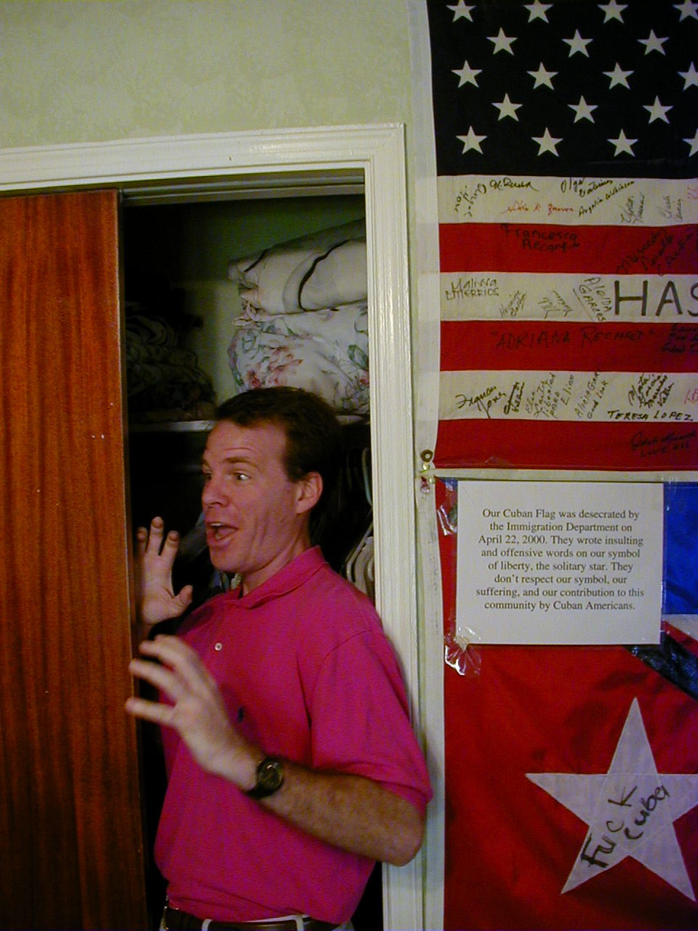

Photo credits: Associated Press and Seth A. Hollander.

