Cylindrical Coordinates for Mathematicians

$$x=r\text{cos}θ y=r\text{sin}θ z=z$$
Warning: Physicists use ρ and φ instead of r and θ.

Surfaces on which one variable is constant.
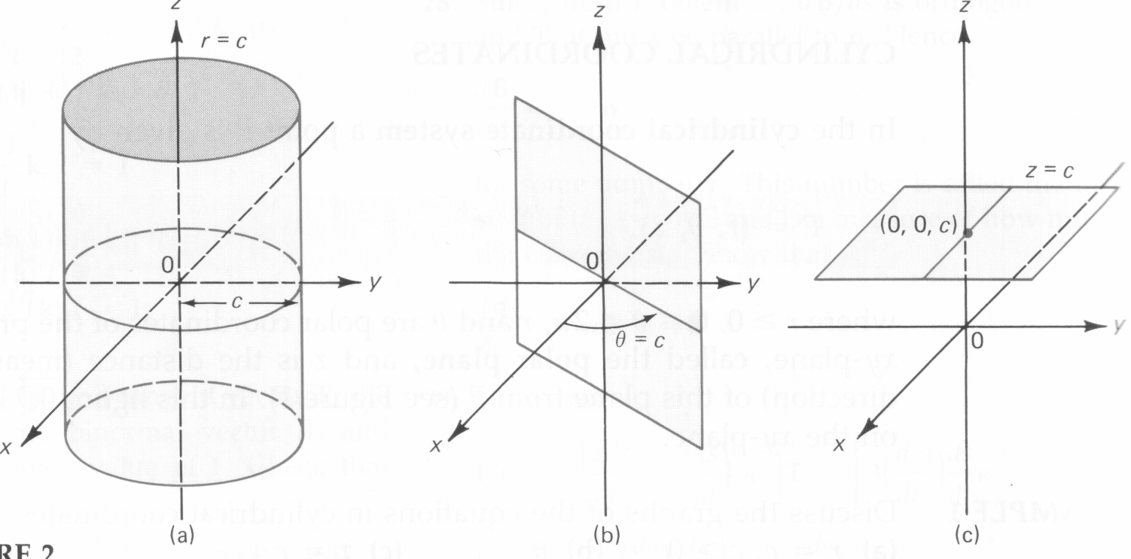

Volume element
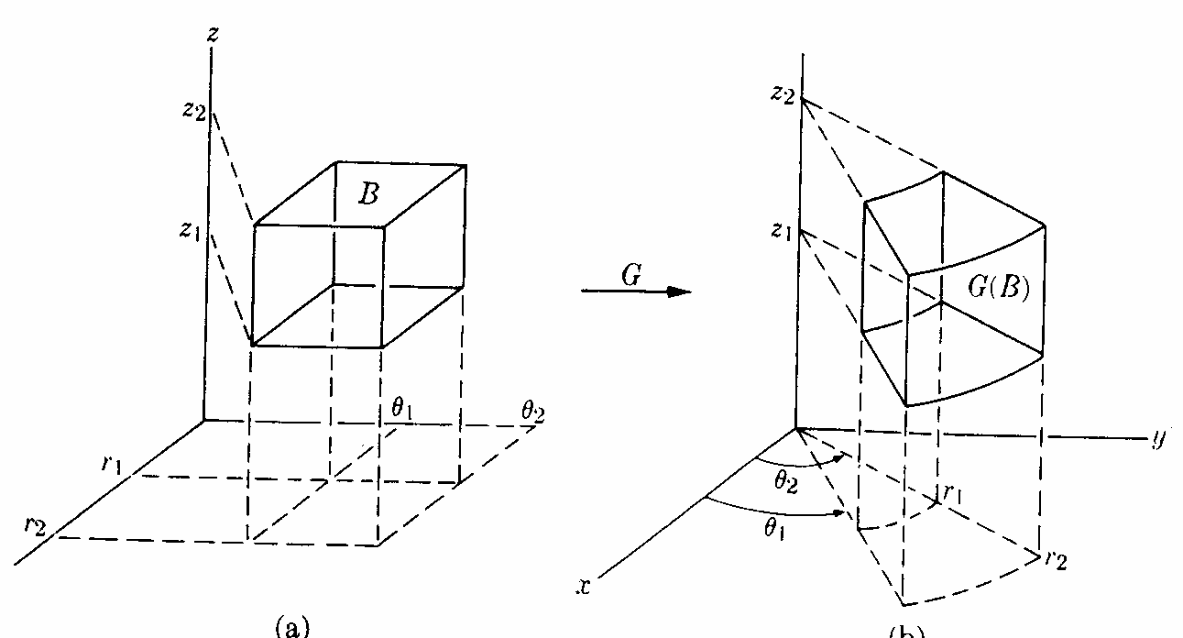
$$\text{dV}=r \text{dz} \text{dr} dθ$$
Spherical Coordinates for Mathematicians

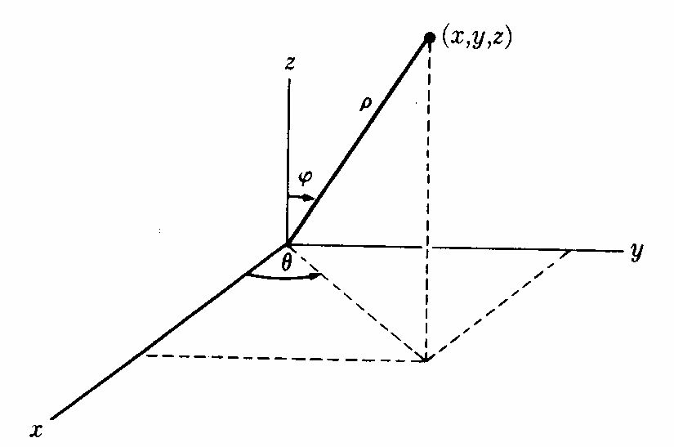
$$x=ρ\text{sin}ϕ\text{cos}θ y=ρ\text{sin}ϕ\text{sin}θ z=ρ\text{cos}ϕ$$
Warning: Physicists use r instead of ρ and they switch φ and θ!

Surfaces on which one variable is constant.
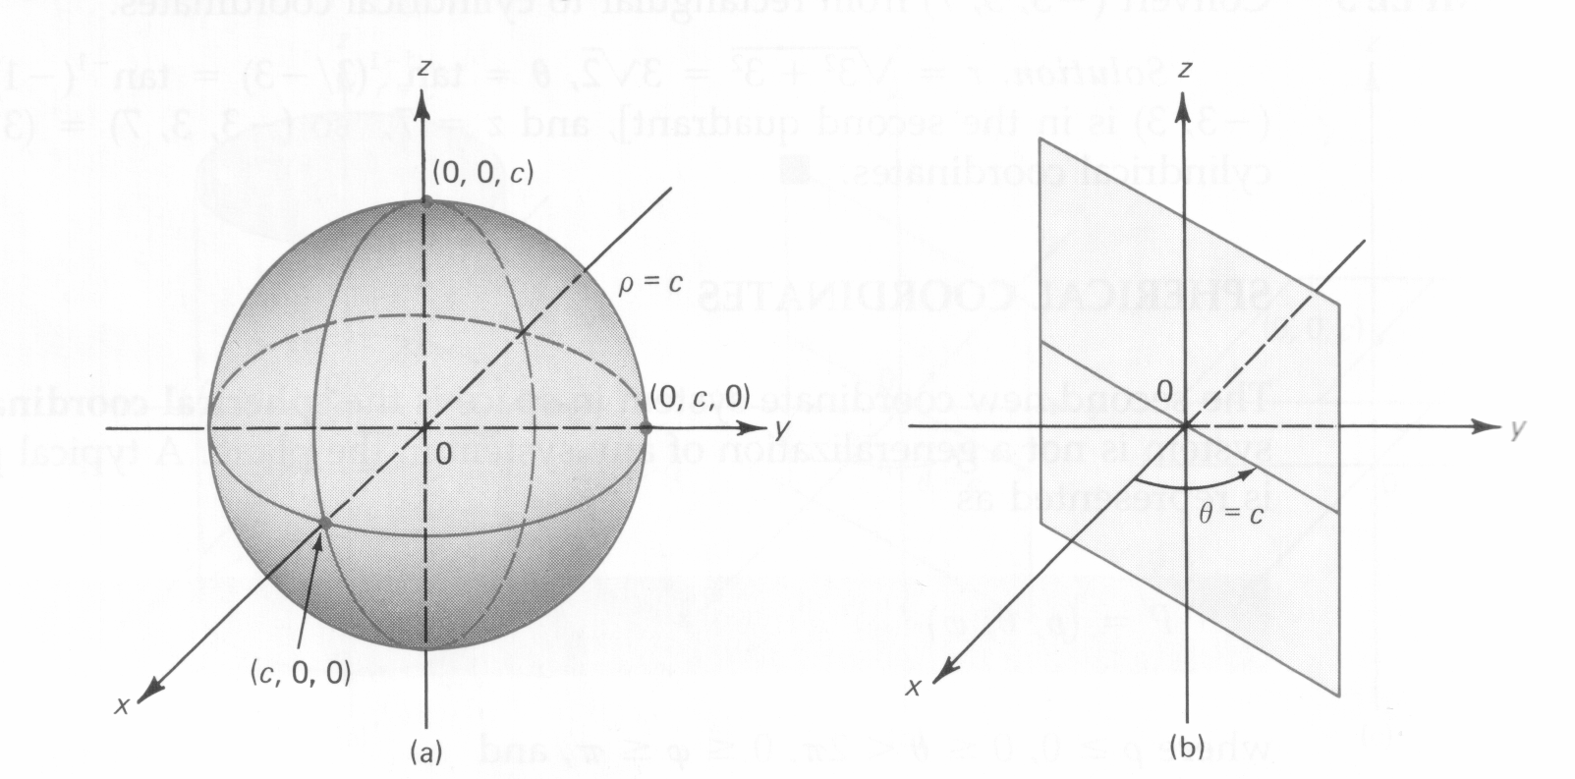

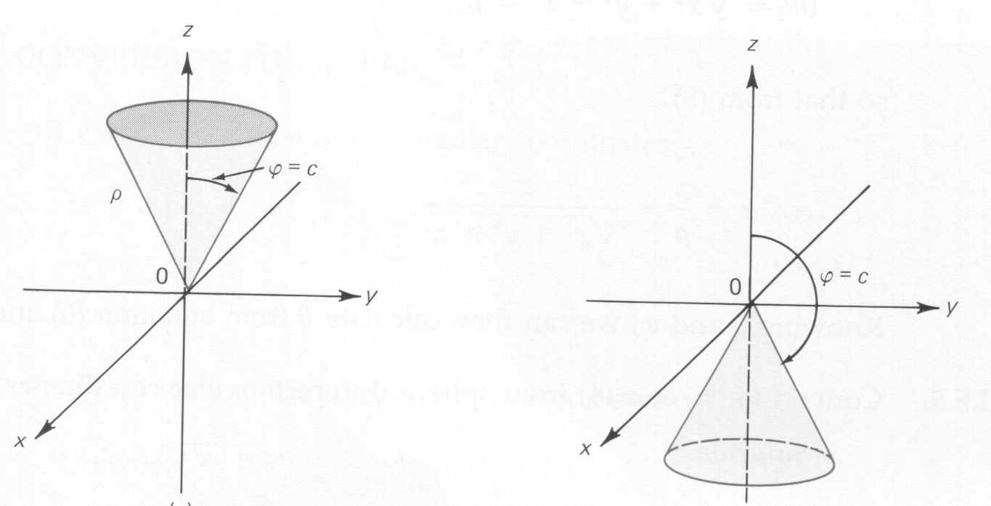
Volume element
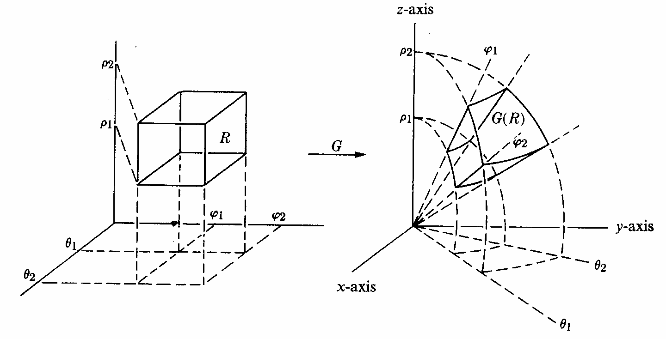
$$\text{dV}=ρ^{2}\text{sin}ϕ dρ dϕ dθ$$

Both Coordinate Systems Together

